**INFO 6205**

**Program Structures & Algorithms**

**Fall 2020**

**Assignment No**

* **Task**
* **Output** (few outputs to prove relationship)
* **Relationship conclusion**
* **Evidence to support relationship** (screen shot and/or graph and/or spreadsheet)
* **Screenshot of Unit test passing**

**This picture is proof of my program's success.** 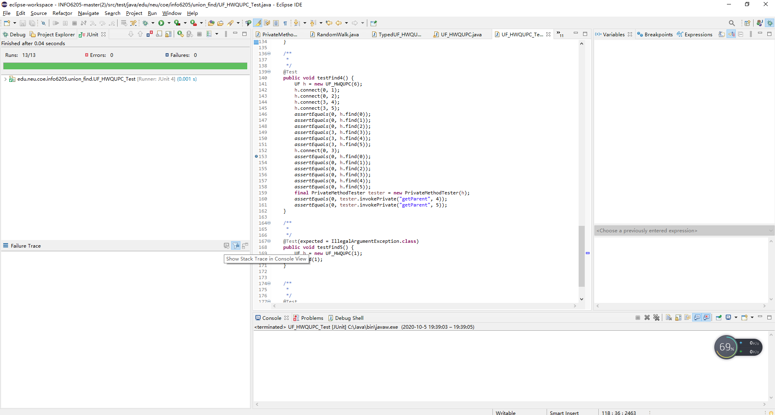

**I set the value of N to 100,225,400,800,1000,1600,2000 then ran the program and took a screenshot of the result.**

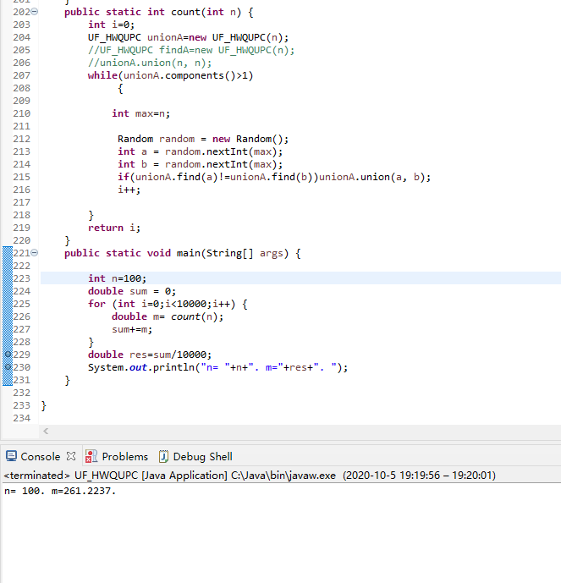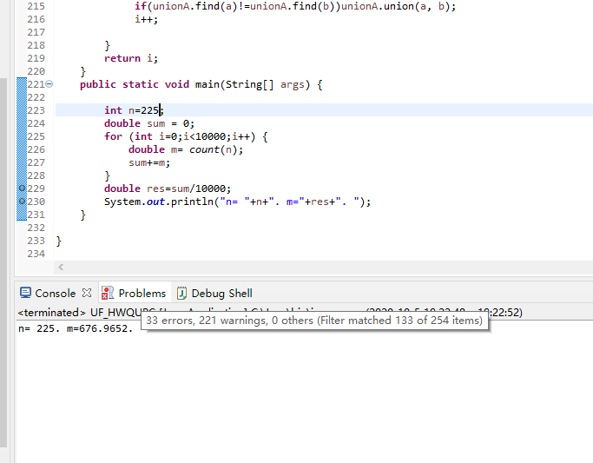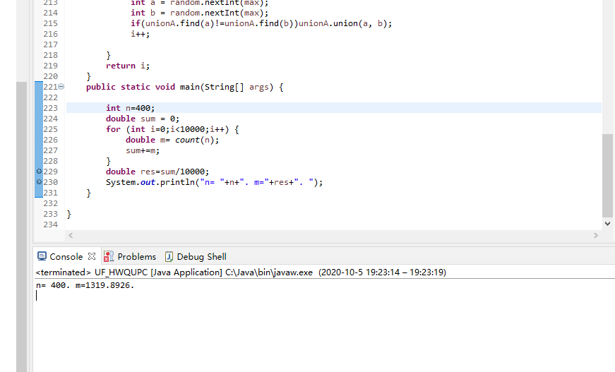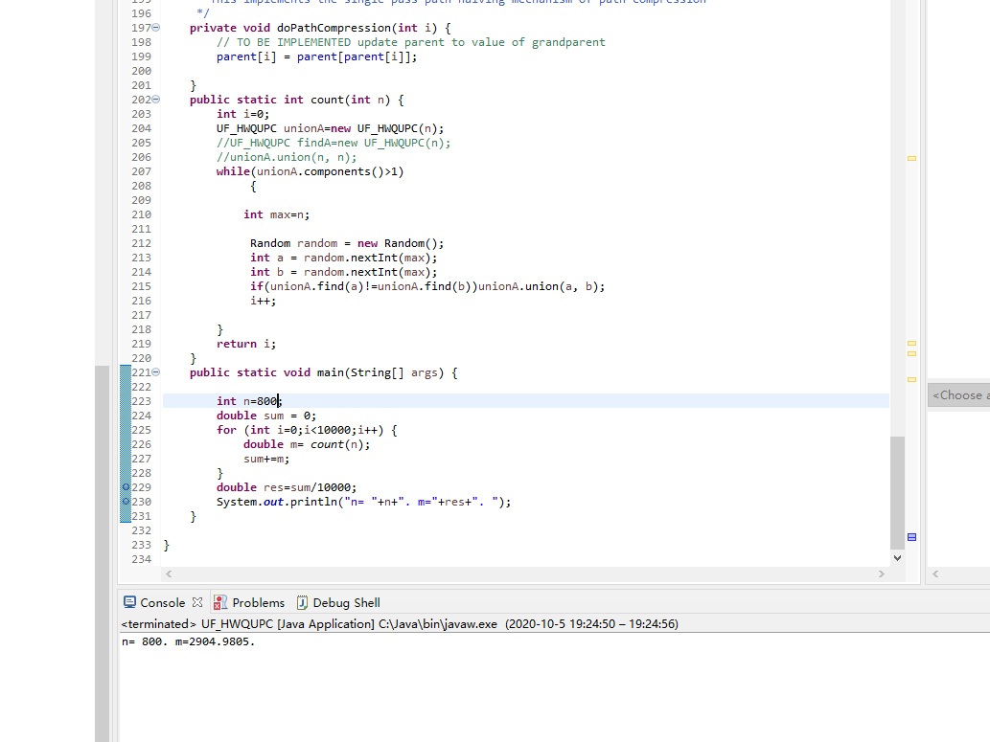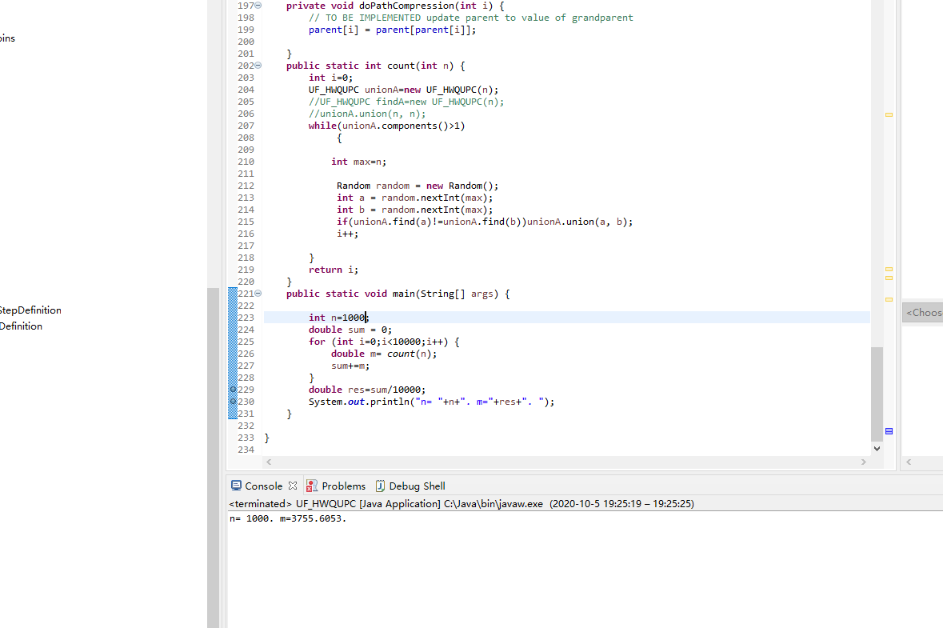

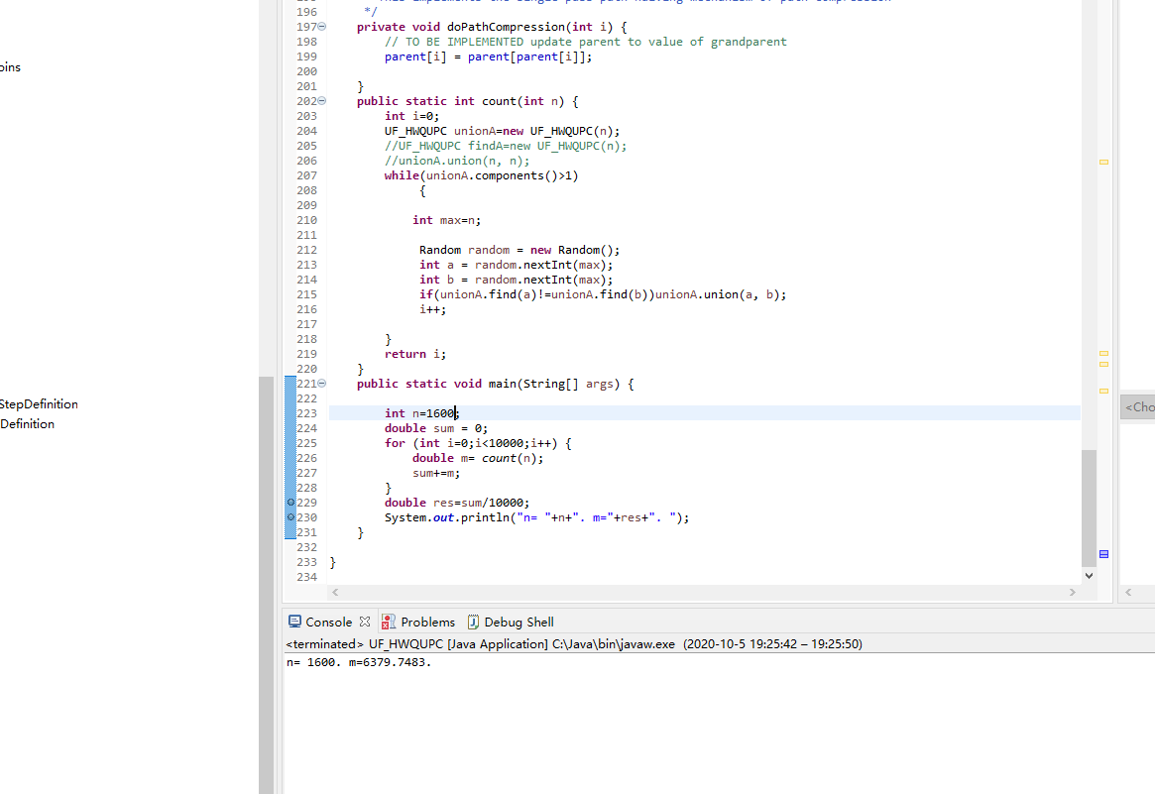

**Then I'll tabulate the data I get.**

|  |  |
| --- | --- |
| n | m |
| 100 | 261.22 |
| 225 | 676.96 |
| 400 | 1319.89 |
| 800 | 2904.98 |
| 1000 | 3755.6 |
| 1600 | 6379.74 |
| 2000 | 8185.76 |
|  |  |

**Then I tried to find their relationship**

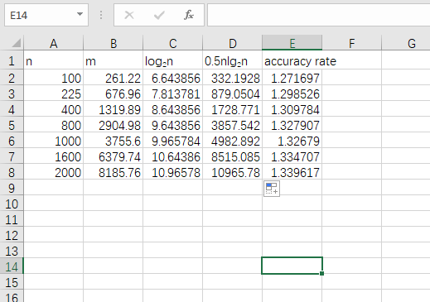

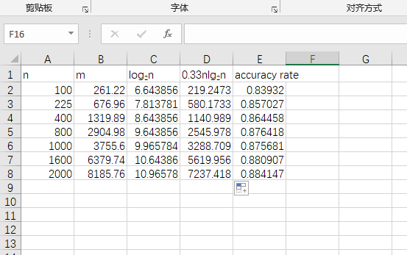

**At this point I'm sure the coefficient should be between 0.33 and 0.5.**

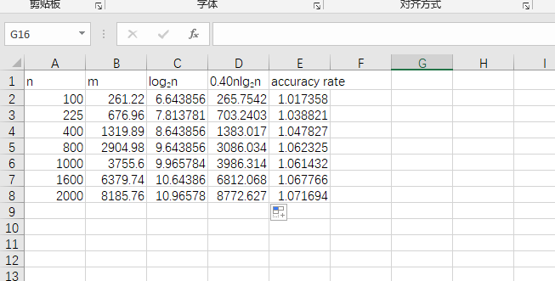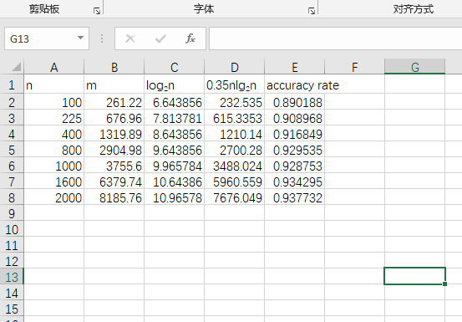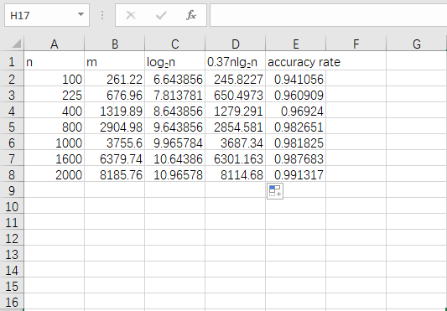

**By changing the constant, the relationship between n and m becomes clearer and clearer. When the coefficient reaches 0.37, the accuracy exceeds 95% and gets closer and closer to 100%.**

**So, I think that m**≈**0.37nlog2n**